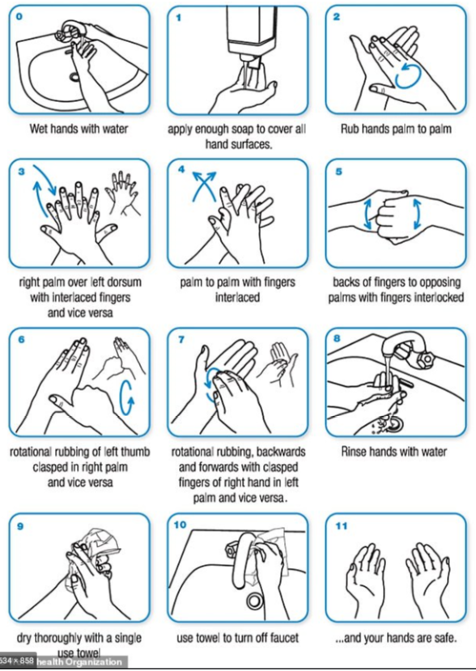

Wash duration for a minimum of 20 seconds

